EXP-3
E- Commerce Mobile App Prototype (Figma)
Aim
To design a prototype for stakeholder feedback.
Procedure
1. Create a mobile frame in Figma.
2. Design Home, Product Page, Cart, Checkout.
3. Create two UI variations (to resolve conflict).
4. Present to stakeholders for feedback.
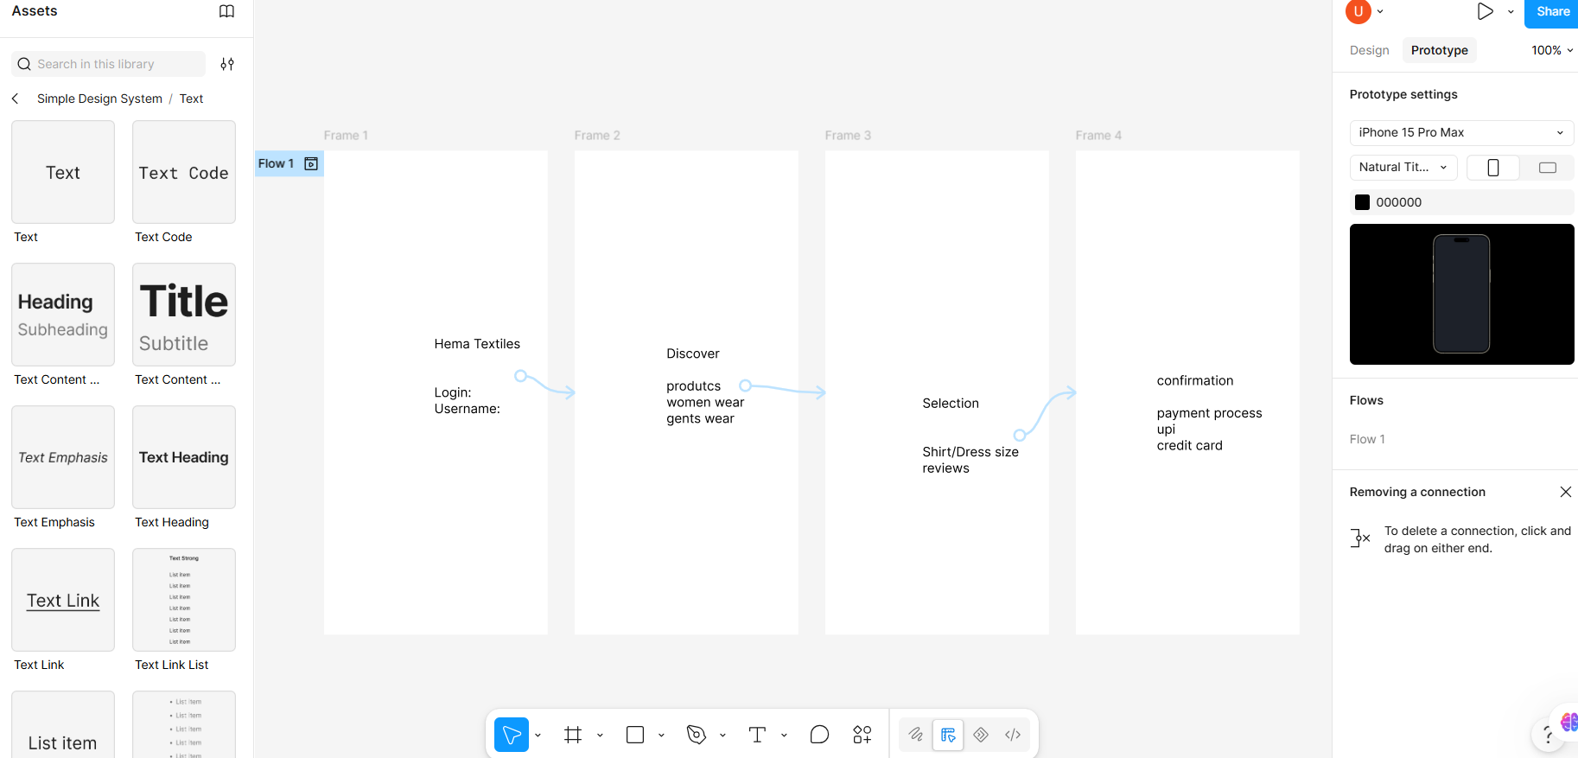
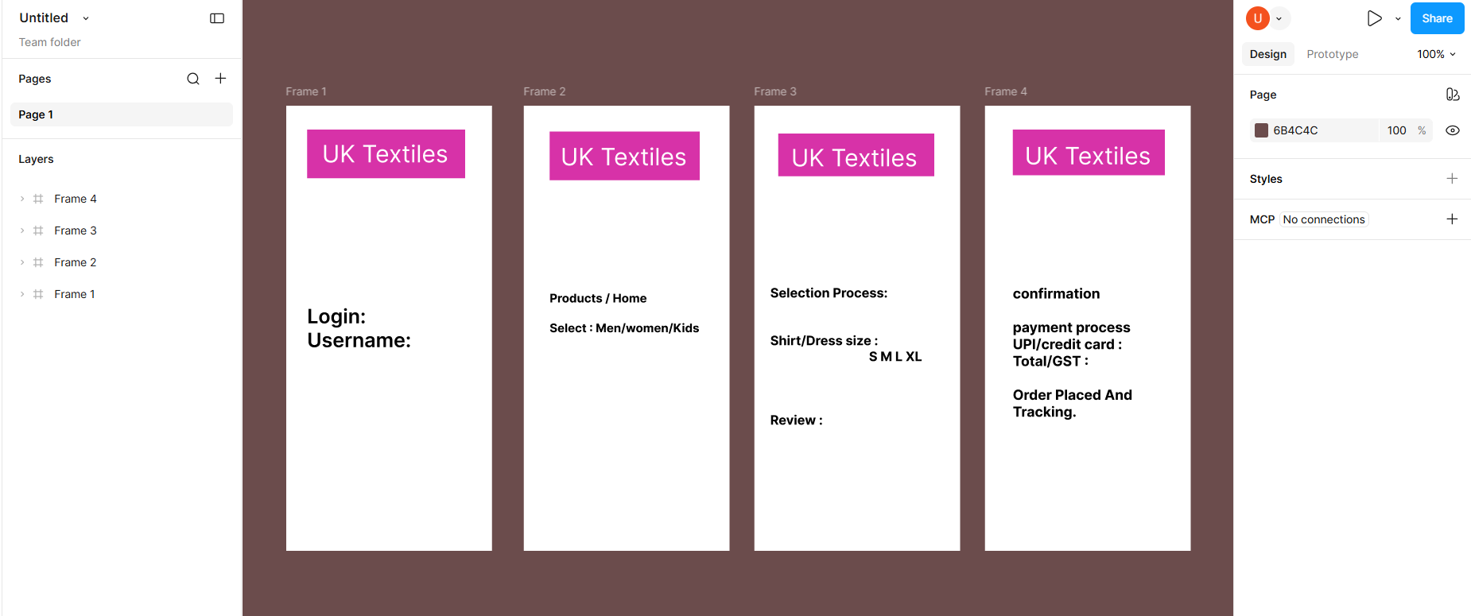

Result: Thus, The Prototype created and stakeholder feedback collected for UI finalization.

